**SMART BRIDGE EXTERNSHIP MODERN WEB APPLICATION DEVELOPMENT WITH SPRING BOOT**

**Project: Movie Ticket Booking Application with Spring Boot**

**Team Members:(Team no: 209)**

* **Pallapothu Sri Akash(20BCB0027)**
* **Sujit S Bagdure (20BDS0098)**
* **Nelakurthi Akash Reddy (20BCE2216)**
* **Hemanth Gubbala(20BCE2319)**

**INTRODUCTION**

1.1 Overview:

The movie ticket booking system is a web-based application developed using the Spring Boot framework. It aims to provide users with a convenient and efficient platform for booking movie tickets online. The system allows users to browse available movies, select preferred showtimes, choose seating options, and make secure online payments. With this application, users can easily book movie tickets from the comfort of their homes, eliminating the need for physical ticket purchases and long waiting lines at theaters.

1.2 Purpose:

The purpose of this project is to streamline the movie ticket booking process and enhance the overall user experience. By leveraging Spring Boot's features and capabilities, the project aims to achieve the following:

Simplified Booking Process: The project intends to simplify the ticket booking process by providing users with a user-friendly interface to search for movies, view showtimes, and select preferred seats. It eliminates the need for users to visit theaters in person or make phone calls for ticket reservations.

Convenient Access: The project enables users to access the movie ticket booking system anytime and from anywhere with an internet connection. Users can conveniently book tickets from their homes, offices, or even while on the go using their preferred web browsers.

Time and Effort Savings: By eliminating the need for physical ticket purchases and long queues, the project saves users' time and effort. Users can quickly browse available movies, check seat availability, and complete the booking process within minutes.

Secure Online Payments: The project incorporates secure payment gateways to ensure that users can make online payments for their ticket bookings with confidence. It adopts industry-standard security measures to protect users' sensitive financial information.

Real-time Updates and Notifications: The project provides real-time updates on movie availability, showtimes, and seat occupancy. Users receive notifications for booking confirmations, changes in showtimes, or any other relevant updates.

Efficient Management: The project includes an administration panel that allows theater staff to manage movie listings, add new movies, update showtimes, and track bookings. It simplifies the administrative tasks associated with managing ticket inventory and helps theater owners optimize seat occupancy.

2 LITERATURE SURVEY

Online Ticket Booking Application with Spring Boot

2.1 Existing Problem:

The existing problem in online ticket booking applications is the lack of efficient and user-friendly systems. Some common issues faced by users include slow performance, limited functionality, inadequate security measures, and poor user experience. Additionally, existing applications often lack real-time updates, leading to difficulties in managing bookings and availability.

Existing Approaches or Methods to Solve this Problem:

Several approaches have been proposed to address the challenges associated with online ticket booking applications. The following are some key existing methods:

* Traditional Web-Based Systems: Many existing ticket booking applications are web-based, allowing users to access the system through a browser. These systems often utilize technologies like PHP, Java Servlets, or ASP.NET. However, they may suffer from scalability issues, suboptimal performance, and complex deployment processes.
* Native Mobile Applications: Some ticket booking applications provide dedicated mobile apps for iOS and Android platforms. Native apps offer improved user experience and can leverage device-specific features. However, developing and maintaining separate apps for different platforms can be resource-intensive.
* Third-Party Aggregators: Various ticket aggregators or marketplaces act as intermediaries between users and ticket providers. These platforms aggregate ticket options from multiple sources and offer a unified interface for users. However, they may introduce additional fees or limitations imposed by the aggregator.
* Cloud-Based Solutions: Cloud computing technologies have facilitated the development of scalable and reliable ticket booking systems. These solutions leverage cloud platforms like Amazon Web Services (AWS) or Microsoft Azure to handle the application's infrastructure needs. Cloud-based systems offer advantages such as high availability, scalability, and fault tolerance.

2.2 Proposed Solution:

The proposed solution for developing an online ticket booking application is to leverage the Spring Boot framework. Spring Boot provides a robust foundation for building Java-based applications, allowing for rapid development and deployment. The following key features can be incorporated into the proposed solution:

* Microservices Architecture: Adopting a microservices architecture enables modular development and scalability. Each component of the ticket booking application can be developed as a separate microservice, such as user management, ticket inventory, payment processing, and notifications.
* RESTful APIs: Implementing RESTful APIs allows for easy integration with various client applications, such as web browsers, mobile apps, or other systems. RESTful APIs enable communication between the front-end and back-end components, ensuring efficient data exchange.
* Database Management: Utilize an appropriate database management system (e.g., MySQL, PostgreSQL) to store and manage data related to users, bookings, ticket availability, and other relevant information. Ensure proper data modeling and indexing techniques to optimize query performance.
* Real-time Updates: Implement mechanisms to provide real-time updates to users regarding ticket availability, booking confirmations, or any changes to existing bookings. Websockets or server-sent events (SSE) can be utilized to enable real-time communication between the server and client applications.
* Security Measures: Incorporate security practices such as user authentication, authorization, and secure communication (HTTPS). Apply encryption techniques to protect sensitive data, implement secure session management, and adopt industry-standard security frameworks.
* User Experience: Focus on designing an intuitive and user-friendly interface that facilitates seamless ticket searching, selection, and booking processes. Implement features like personalized recommendations, seat selection, and easy payment options to enhance the overall user experience.

**3 THEORETICAL ANALYSIS**

**3.1 Block diagram:**

* The block diagram illustrates how the various components interact to enable movie ticket booking functionality. Users and administrators access the system through web browsers, interacting with the frontend user interface. The frontend communicates with the backend via RESTful APIs, allowing users to search for movies, select seats, make bookings, and view booking details. The backend processes these requests, interacts with the MySQL database to store and retrieve data, and may also integrate with external services such as payment gateways and notification services to handle specific tasks.

**BLOCK DIAGRAM:**

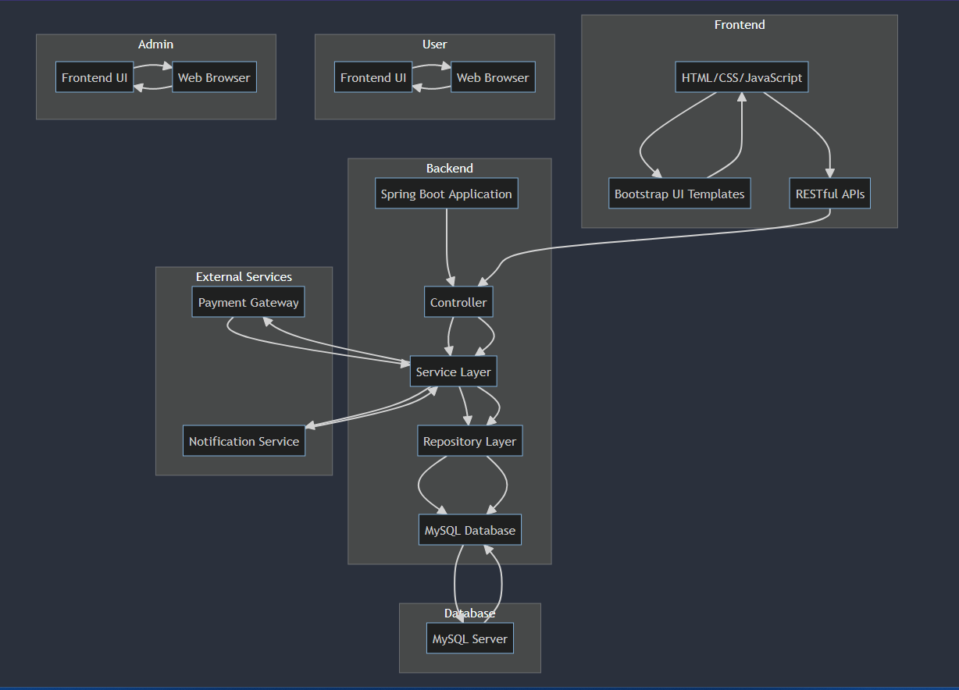

* **DATABASE EER Tables**

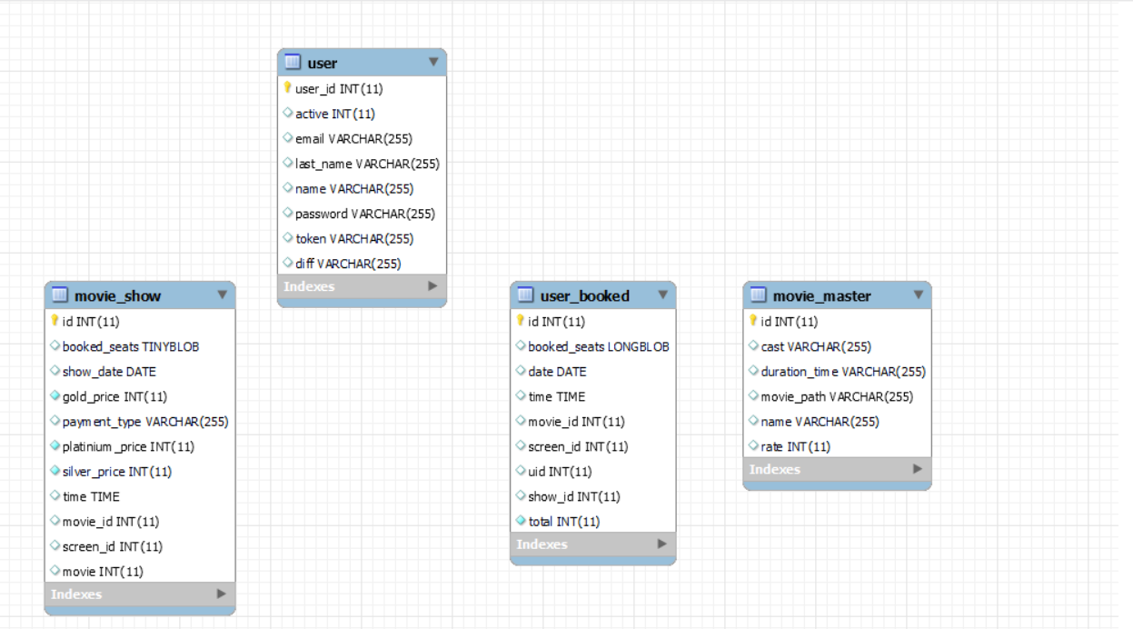

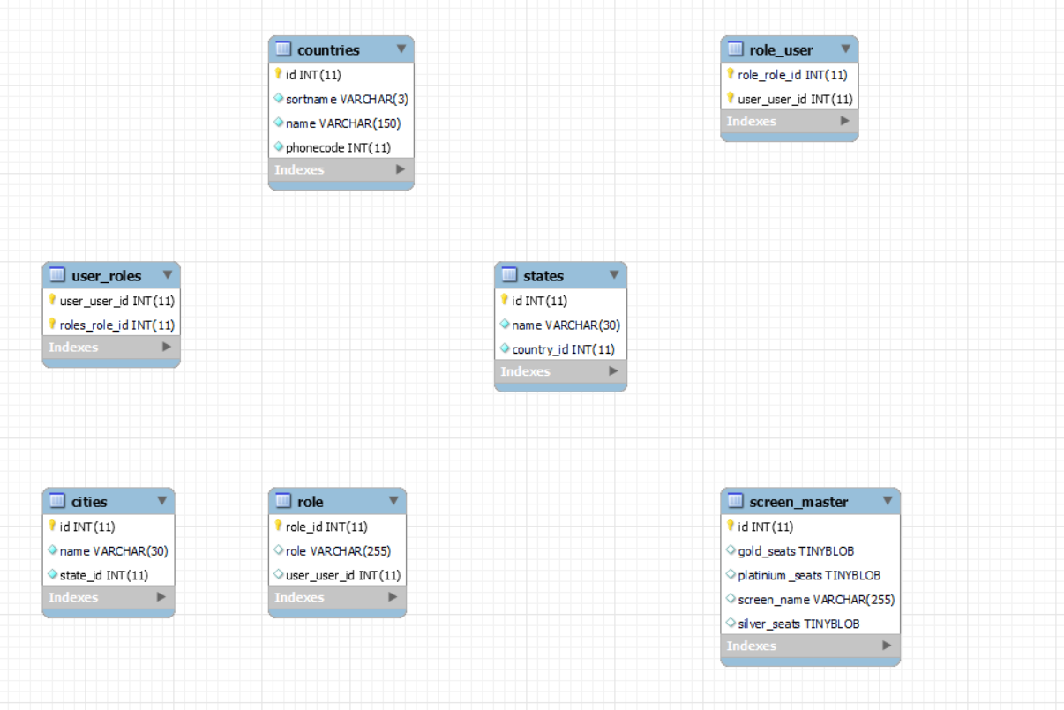

3.2 Hardware / Software designing

Software Resource Requirements

1- Java Development Kit (JDK):JDK is required to compile and run Java applications, providing the necessary tools and libraries.

- Download JDK: https://www.oracle.com/java/technologies/javase-jdk11-downloads.html

2- Integrated Development Environment (IDE): An IDE offers a comprehensive development environment for writing, debugging, and managing code. IntelliJ IDEA, Eclipse, or Visual Studio Code are popular choices for Java development.

- Eclipse: https://www.eclipse.org/downloads/

3-Spring Boot: Spring Boot simplifies Java application development by providing predefined configurations, automatic dependency management, and a streamlined development experience. Use Spring Initializr or Spring Tools for your IDE to create a Spring Boot project.

- Spring Initializr (Online): https://start.spring.io/

- Spring Tools 4 for Eclipse: https://spring.io/tools

4-MySQL Database: MySQL is a popular relational database management system. Install MySQL Community Server and optionally MySQL Workbench, a graphical tool for managing MySQL databases.

- MySQL Community Server: https://dev.mysql.com/downloads/installer/

- MySQL Workbench: https://dev.mysql.com/downloads/workbench/

5-MySQL Connector/J:MySQL Connector/J is the official JDBC driver for connecting Java applications to MySQL databases. Include this dependency in your project to enable connectivity and interaction with MySQL.

- Maven:

- Add the following dependency to your project's pom.xml:

xml

<dependency>

<groupId>mysql</groupId>

<artifactId>mysql-connector-java</artifactId>

<version>8.0.27</version>

</dependency>

- Maven Repository: <https://mvnrepository.com/artifact/mysql/mysql-connector-java>

3.3 Key Features and Functionality:

Movie Listing: The system displays a comprehensive list of available movies, along with details such as genre, cast, synopsis, and ratings. Users can browse through the movie catalog to explore different options.

Showtime Selection: Users can view the showtimes for each movie and select the preferred screening time based on their convenience. The system displays available showtimes for each movie, allowing users to choose the most suitable option.

Seat Selection: Once the movie and showtime are selected, users can view the seating layout of the theater and choose their desired seats. The system provides a graphical representation of the theater layout, indicating seat availability.

Booking and Payment: After selecting seats, users can proceed to book the tickets and make payment using secure payment gateways. The system ensures a smooth and secure transaction process, offering multiple payment options.

User Registration and Login: To access the booking functionality, users are required to create an account or log in to an existing account. User registration enables personalized features, such as booking history, saved preferences, and promotional offers.

Booking Management: The system provides administrators with a dashboard to manage movie listings, showtimes, and bookings. Administrators can monitor seat availability, add or remove movies, and view booking details.

Real-time Updates and Notifications: Users receive real-time updates regarding seat availability, booking confirmations, and any changes to showtimes or cancellations. The system sends notifications via email or SMS to keep users informed.

**4 EXPERIMENTAL INVESTIGATIONS**

1. Designing and implementing the database schema:
   * The database schema was designed to store movie details, showtimes, seats, and bookings.
   * Tables were created to store information such as movie title, genre, duration, showtime schedules, seat availability, and customer bookings.
   * Relationships between tables were established to ensure data integrity and efficient retrieval.
2. Integrating Spring Boot with MySQL:
   * Spring Boot was used as the backend framework to handle the business logic and provide RESTful APIs.
   * MySQL was chosen as the database management system for data storage.
   * The Spring Data JPA framework was utilized to establish the connection between the application and the MySQL database.
   * Database operations, such as inserting movie details, retrieving showtimes, updating seat availability, and storing bookings, were implemented using Spring Data JPA.
3. Implementing user authentication and authorization:
   * User authentication and authorization functionality was implemented to differentiate between customer and admin roles.
   * Spring Security was integrated into the application to handle user authentication and authorization.
   * Customers and admins were provided with separate login interfaces, and their access to different sections of the application was controlled based on their roles.
   * User credentials were securely stored and validated during the authentication process.
4. Testing the application for various scenarios:
   * The application was extensively tested to ensure its functionality and performance in various scenarios.
   * Test cases were created to validate seat availability, booking creation, payment processing, and error handling.
   * Different edge cases, such as overlapping showtimes, seat conflicts, and invalid inputs, were tested to ensure the application handled them correctly.

**5. FLOWCHARTS**

* **CLIENT SIDE:**
* 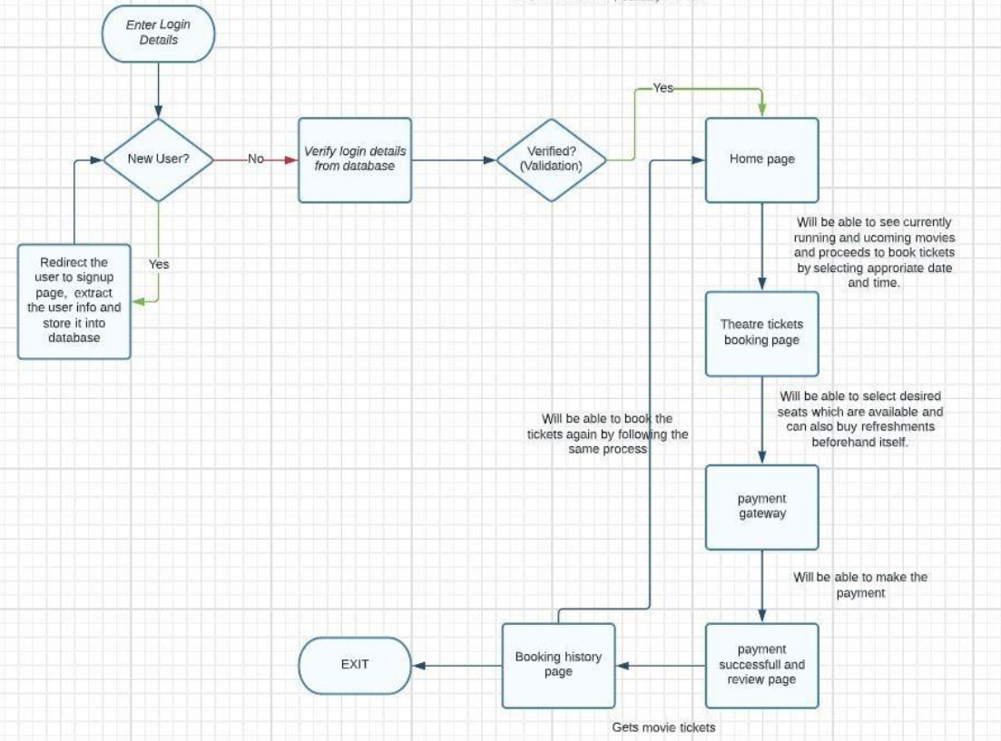
* **ADMIN SIDE:**
* 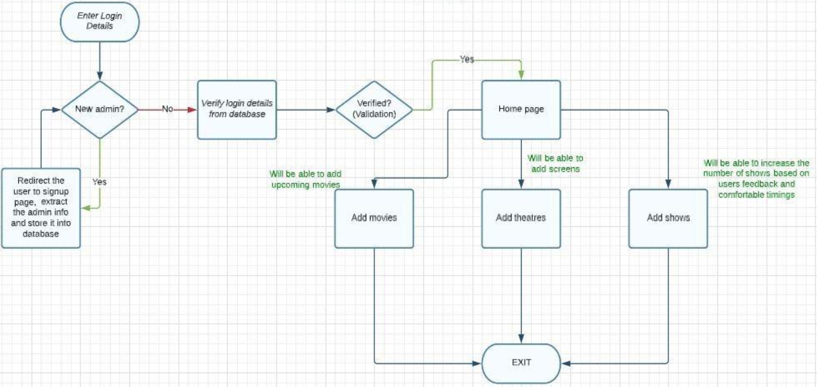

**6 RESULT**

* **Admin Dashboard**

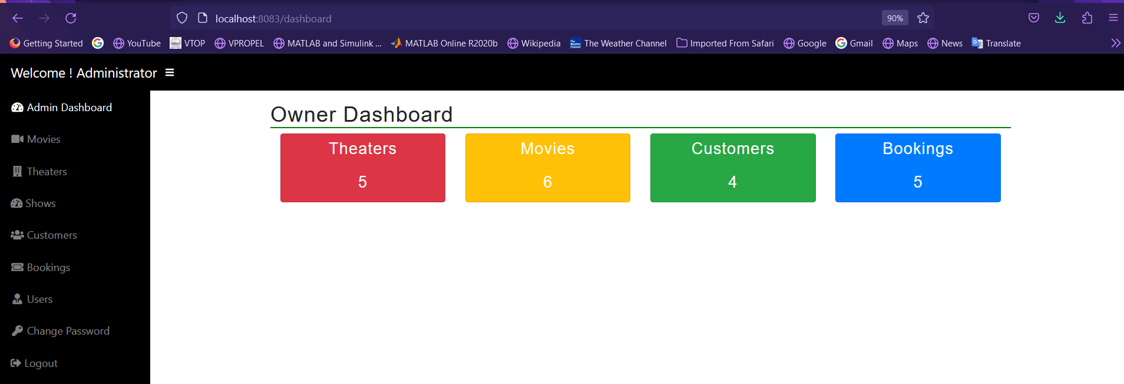

* **Home Page(Customer):**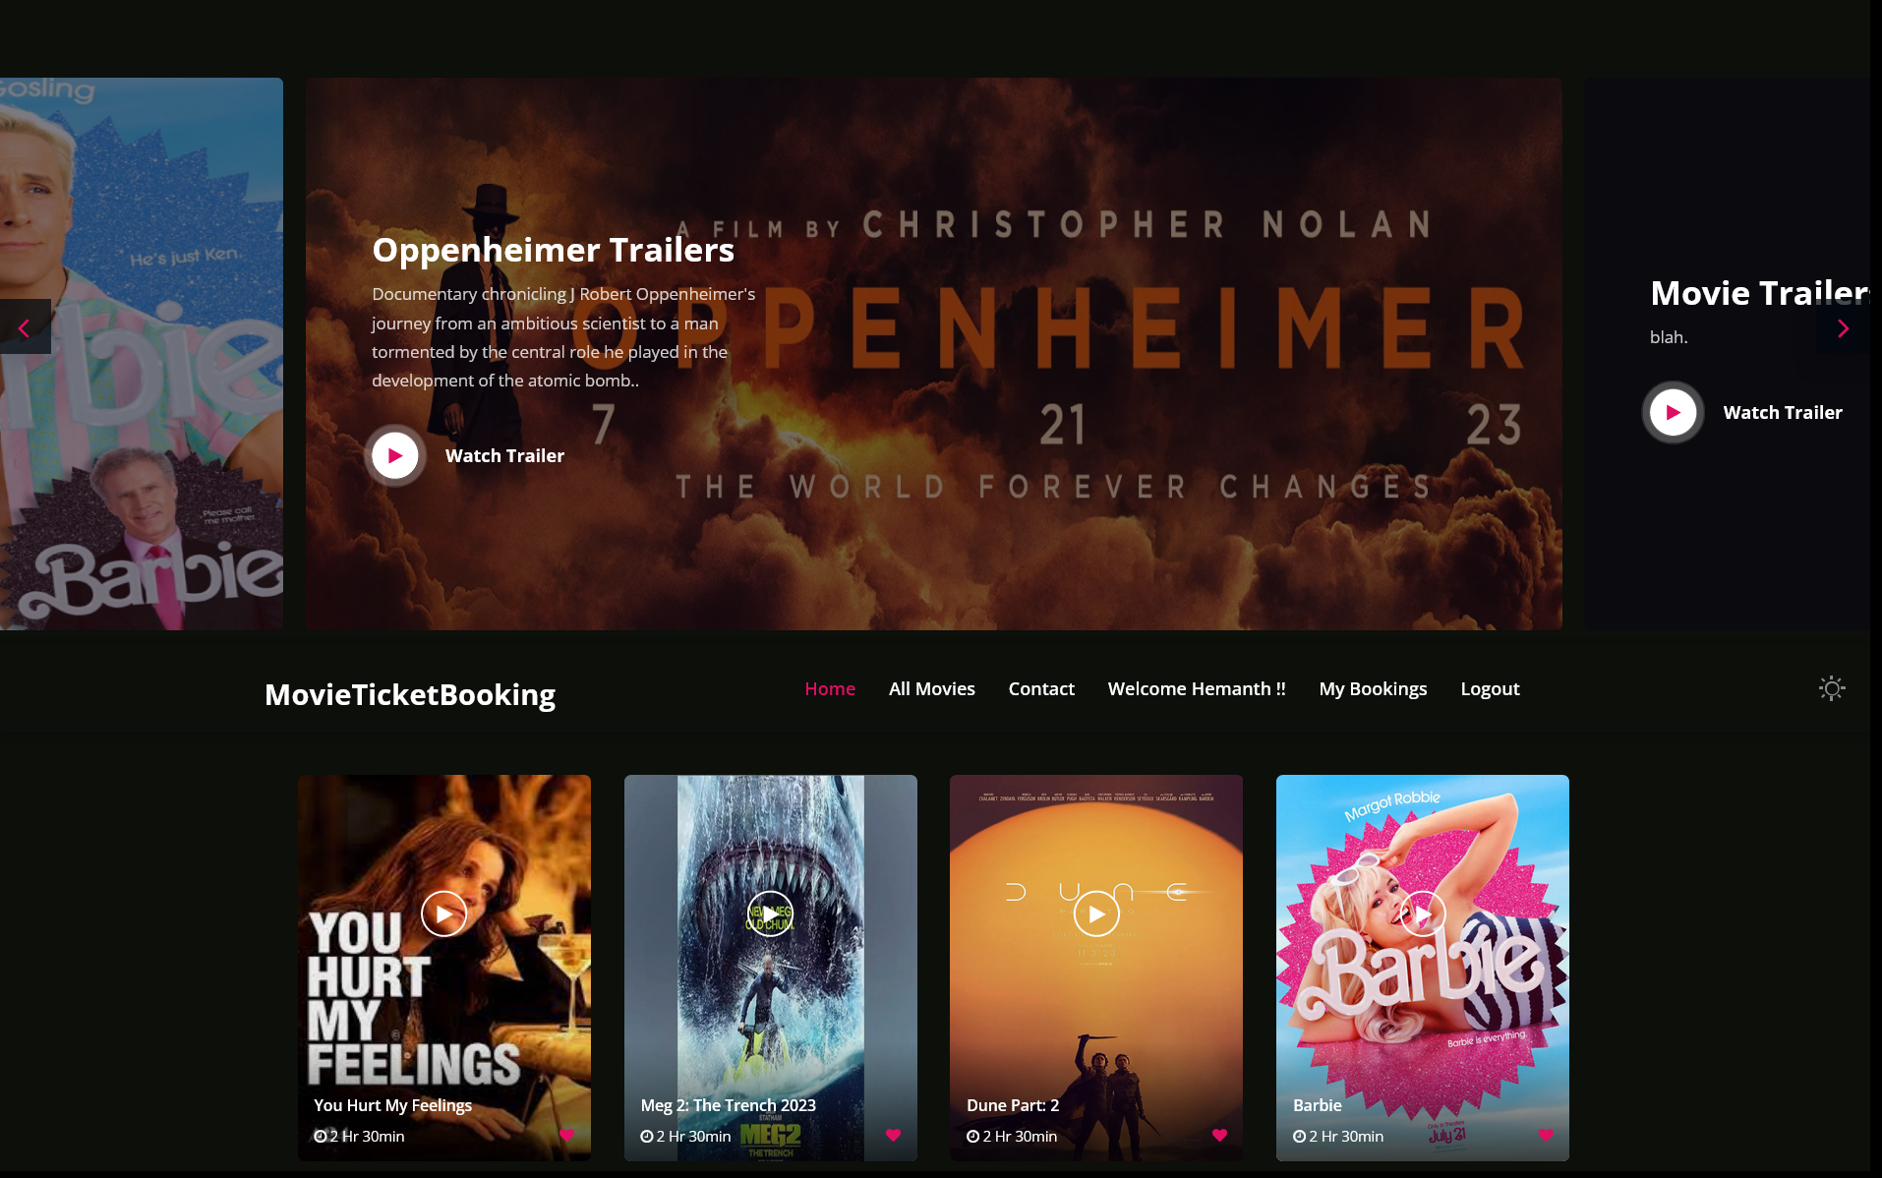
* **Movie Ticket Booking:**

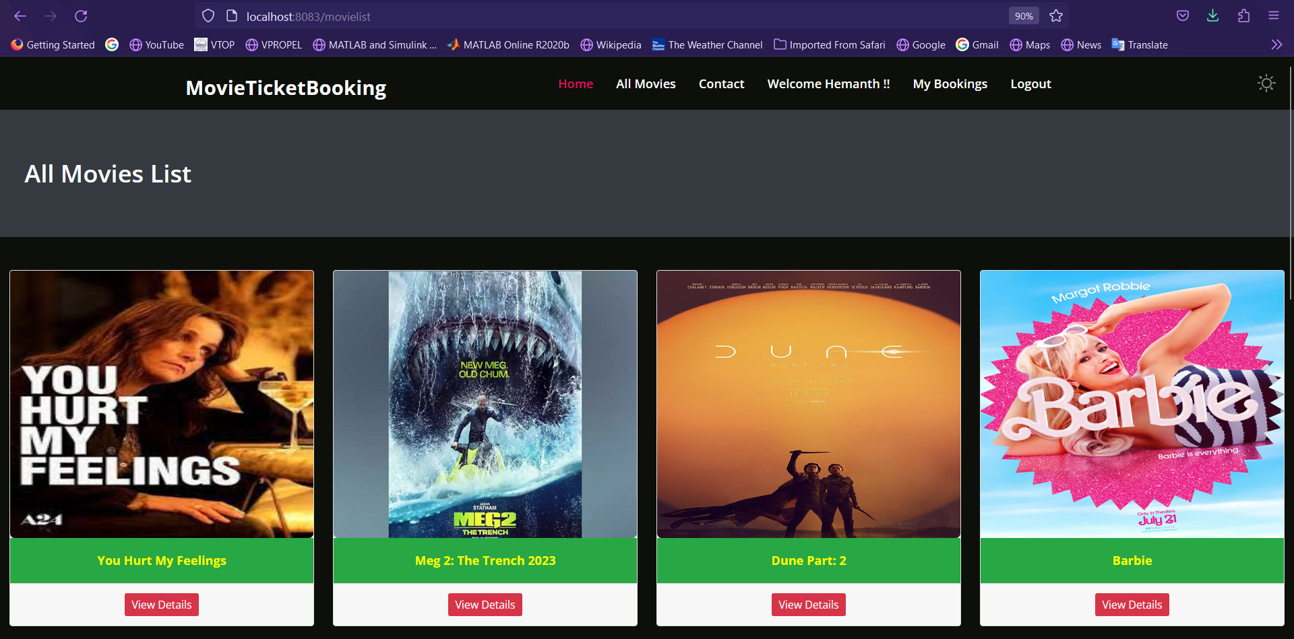

* **Movie Details:**

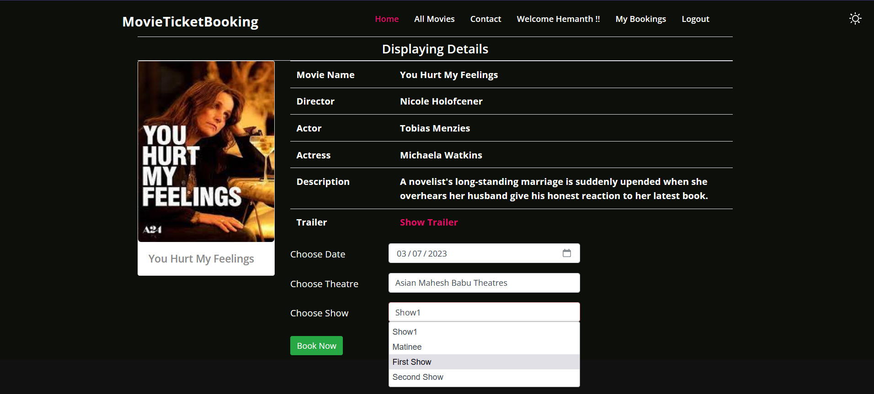

* **Seat Booking Matrix:**

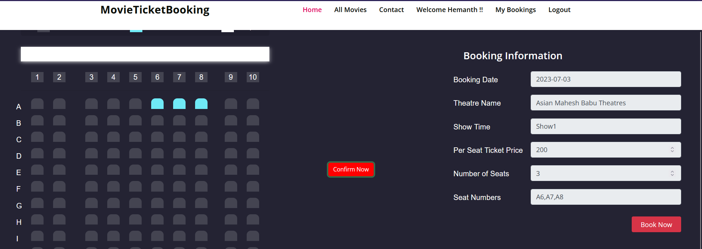

* **Payment window:**

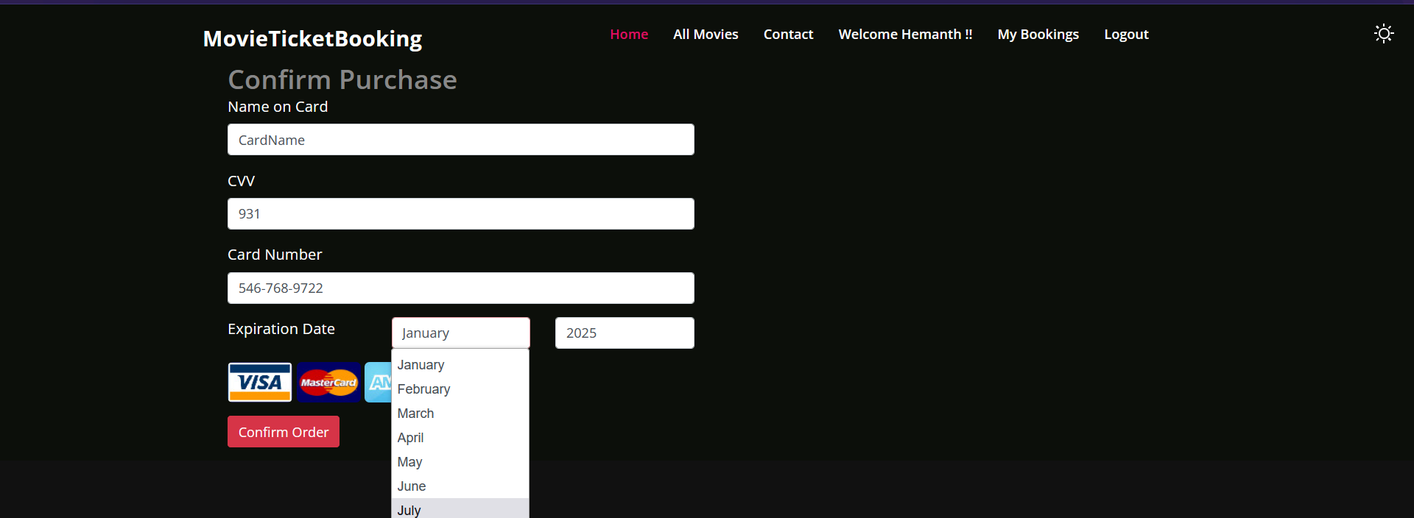

* **Booking History:**

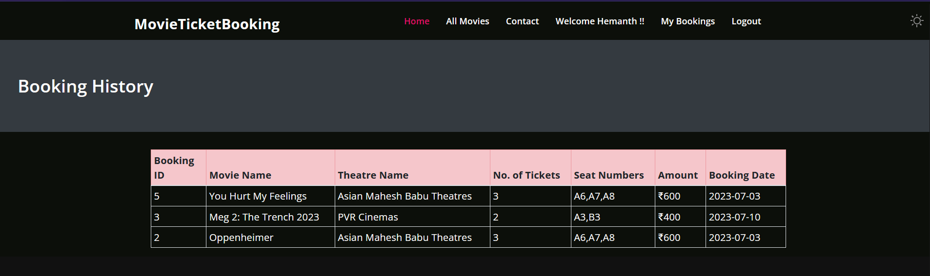

**7 ADVANTAGES & DISADVANTAGES**

The benefits of a movie ticket booking app:

1. Convenience: Users may book movie tickets through a movie ticketing app whenever and wherever they choose, eliminating the need to physically attend the theatre or stand in long lines.

2. Time-saving: By skipping actual ticket counters or calling the theatre to make reservations, users can save time. They may easily search through available movies, look up showtimes, choose seats, and submit payments online.

3. Seat selection: Interactive seat maps are frequently available in booking systems, allowing customers to choose the theatre seats of their choice. This function aids users in selecting seats in accordance with their preferences, improving the viewing experience.

4.Movie reviews and information: These programmes frequently offer comprehensive movie information, such as narrative summaries, actor and crew information, trailers, and user reviews. Based on this information, users can choose which films to view in an informed manner.

5.Offers and discounts: Applications for purchasing movie tickets typically give users access to special discounts, offers, and loyalty programmes. Users can take advantage of these deals to save money on ticket purchases or to get extra benefits like free refreshments or merchandise.

6.Applications can inform users of forthcoming movie releases, showtimes, special screenings, or deals by sending notifications and reminders to their devices. Users can use this tool to keep up with the most recent movie news and stay informed.

Negative aspects of a movie ticket booking app:

1.Applications for purchasing movie tickets may encounter technological difficulties such as server outages, sluggish performance, or problems with payment processing. These problems may irritate customers and interfere with their booking process.

2.Booking applications rely on internet connectivity, thus users must have a reliable internet connection in order to access and utilise the application. The booking procedure may be hampered by poor connectivity or a lack of internet access.

3.Complexities in the user interface: Some users, especially those who are less tech-savvy or belong to an older population, may find it difficult to utilise and navigate the application's user interface. For some people, confusing layouts or instructions can be a problem.

4.Dependence on third-party services: Applications for purchasing movie tickets frequently depend on outside services to handle payments, check for available seats, or get movie information. The operation and user experience of the application may be affected by any faults with these third-party services.

5.Although movie ticket buying apps are widely used, they might not be accessible in all locations or for all theatres. These programmes could be difficult for users to use if they live in distant places or have restricted access to technology.

6.Booking fees and extra costs: Some applications for purchasing cinema tickets tack on convenience or service fees. Users need to be informed that these extra expenses could raise the total cost of the ticket.

**9 CONCLUSION**

In conclusion, the Spring Boot project for movie ticket booking offers an effective method for handling reservations for movie tickets. by putting in place a variety of functionalities. User authentication and authorisation are important components of the movie ticket booking project, allowing only authorised users to access and book movie tickets. The project also includes a detailed database schema design for managing and storing user reservations, theatre information, and movie information. The project has an intuitive user interface that makes it simple for users to navigate and has a positive booking experience. It has features including movie search, seat selection, showtime selection, and safe payment processing.

Additionally, the project for purchasing cinema tickets adheres to industry standards for the organisation, readability, and maintainability of code. To increase code modularity and reusability, it makes use of a number of design patterns and principles, such as the Model-View-Controller (MVC) architecture, dependency injection, and separation of concerns. Overall, the Spring Boot movie ticket booking project shows off the framework's potential for creating a dependable and effective ticket ordering system. Its extensive features, user-friendly interface, and adherence to best practices make it a useful tool for both movie theatre owners and patrons, improving the experience of purchasing movie tickets in general.

**10 FUTURE SCOPE**

The movie ticket booking project developed in Spring Boot has several potential avenues for future expansion and enhancement. Here are some potential areas of future scope for the project:

Mobile Application: Developing a mobile application for the movie ticket booking system can significantly expand its user base and reach. A mobile app would allow users to conveniently book tickets on the go, receive notifications for upcoming movies and offers, and provide a seamless experience across different devices.

Ratings and Reviews: Adding a ratings and reviews feature would enable users to share their feedback and experiences about movies, theaters, and overall services. This can help other users make informed decisions and enhance the credibility of the platform.

Loyalty and Reward Programs: Implementing loyalty programs or reward systems can encourage customer retention and engagement. Users could earn points or rewards for booking tickets, referring friends, or participating in promotional activities, which they can later redeem for discounts, free tickets, or exclusive offers.

Analytics and Insights: Incorporating analytics and reporting capabilities into the project can provide valuable insights for theater owners and administrators. Data analysis on ticket sales, popular movies, peak booking hours, and user preferences can help in decision-making, marketing strategies, and optimizing overall operations.

By exploring these future scope possibilities, the movie ticket booking project can continue to evolve and stay competitive in the dynamic world of online ticketing, providing enhanced features, improved user experiences, and greater convenience for moviegoers.